## Frame work Doc:

assignment Suite.xml will be used to trigger test cases.

Note: All the url and auth token I have taken for example so tests will not passed until wright url and token will be provided. This is a mock framework for automating Rest test cases.

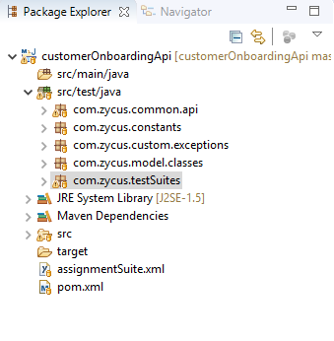

This is a Maven Test-Ng Frame work.

**Com.zycus.common.api**: This package have common utilities classes which can be used inside test. Like Report,RestUtilities, Base test etc. Basically this is a place where other utilities classes can be added.

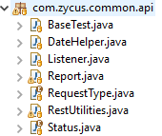

**RestUtilities**: This class have Rest Utilities methods which can be used inside scripts.

**BaseTest.java:** This class have should be extended by all the TestSuite classes**.**

**Report.java: This class impalement extent report for logging.**

**Listener.java:** This class implement IInvokedMethodListener which methods will be trigger before start and after the method invocation. Basically all the pre-requisite things will be done before start of method.

**com.zycus.constants: This method have 3 classes. AuthToken, EndPoints, Path**

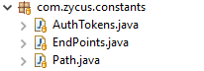

**AuthTokens:** This class will all the auth token required for authentication.

**End Points:** This class will store endpoints related to api.

**Path.java:** This method will store Base Uri and Base Path

For example consider below url.

<https://api.mock.com/account/customers.json>

**Base URI:** https://api.mock.com

**Base PATH:** /account

**End Points:** /customers.json

**com.zycus.model.classes:** In this all the model or pay load classes will be added



**CustomerModel.java: This class have Customer pay load . This will be used as Pojo Classes.**

**com.zycus.testSuites:** In this package we can store all the test suite classes like Regression, Acceptance, Smoke suites etc.



**AssignmentTestSuite.java: This class have all the test cases related to mock test.**



**Pom.xml:** In this will add all the dependencies required for building framework

**assignmentSuite.xml: Run this as test-ng to run all the test cases in AssignmentTestSuite.**